Access Control System Based on Biometric Data
Assoc. Prof. Kamen Spassov, PhD, MBA, Sofia University
Prof. Kyoung Yul Bae, PhD, Sangmyung University

Abstract:
As a result of an ITCC project an access control system based on biometric data was developed. Fingerprint is scanned, processed and the generated hash value is saved on a chip-card or in a database. To grant access to certain resources the system requires the hash value generated with a newly scanned fingerprint to match the hash value recorded on the chip or in the database.
Keywords: biometric, fingerprint, control system, access control
Introduction
Identification of individuals at Bulgarian state and municipality offices is based on visual comparison by the clerk of the face and the picture on the personal identification document (ID Card, Passport, etc.) In these cases the process requires time delay and the identification of a person fully depends of the emotional and health state of the clerk.
In administrations, businesses, and education in many cases it is essential to identify a person in order to grant access to certain resources – premises, software, data etc. Different approaches to identify a person exist. Many of them are vulnerable to counterfeiting.
A biometric recognition can avoid in a larger scale the time consuming and the subjective decisions of the employees at administrations, companies, education institutions, etc.
To investigate the problem and to develop solutions the project Access Control System Based on Biometric Data was launched. The main goal was to develop working prototypes and to look for opportunities for commercialization.
The Team
The team was formed by Associate Prof. Kamen Spassov, Prof. Kyoung Yul Bae, and two Master degree students Mr. Vladimir Korichkov and Mr. Gyu Sub Kim from Sofia University and Sangmyung University.
The team worked remotely with 3 exchange visits:
- Prof. Bae visited Sofia University May 6-9, 2012
- Assoc. Prof. Spassov and Mr. Korichkov visited Sangmyung University Sep 22-28, 2012
- Prof. Bae and Mr Kim visited Sofia University Dec 14-17, 2012
Prof. Nedyu Popivanov and Mr. Yoon from Bulgaria-Korea IT Cooperation Center at Sofia University played a crucial role supporting the project.
Scope of work
The main goal of the project was to develop few prototypes of access control systems based on biometric data (fingerprint).
Another goal was to look for commercialization opportunities.
Works
All prototypes were built using fingerprint scanners and devices from Korean manufacturers utilizing the same two phase approach:
- Enrolment

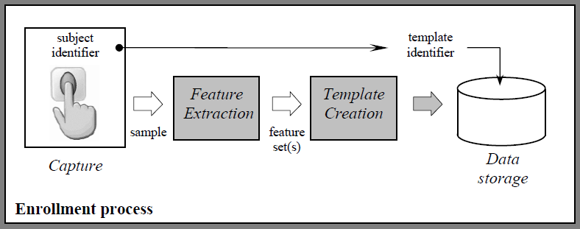
Figure 1. The enrolment process is needed to acquire users’ biometric data (fingerprints). The specific is that instead of storing fingerprint images the system produces hash values that are stored. In this case data storage could be a database, USB memory or chip card.
- Verification
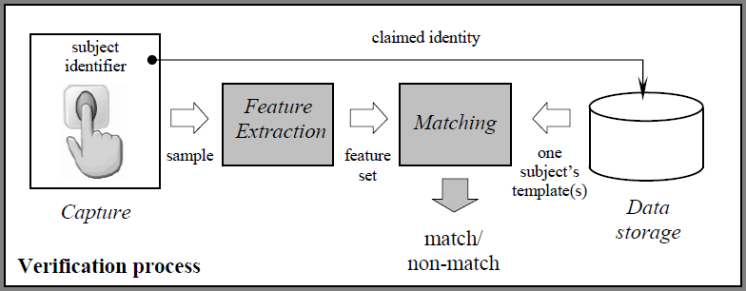
Figure 2. Fingerprint verification is used to identify the user and based on this to authorize them to access certain resources. Instead of comparing images the system compares hash values
In general all prototypes (HW+SW) provide verification and authorization of users after initial enrolment. Fingerprints are stored as hash functions not as images in a database, USB memory or chip card.
As a result of joint efforts the following prototypes were produced:
- Access control to corporate systems based on fingerprints using a mouse with integrated fingerprint scanner. User profiles (levels of access to different systems) are defined with the respect of the roles of users. Fingerprints are collected and stored into an encrypted data base. Identification of users is based on fingerprint. Authorization is grounded on their roles.

- A simple representation of such a system is a personal computer with a mouse with integrated scanner (Picture 1). Different users get access to different user’s profiles based on their fingerprint. In this case it is possible to establish one factor (password or fingerprint) or two factor (password and fingerprint) authentication to ensure secure access to the system. Using a mouse with an integrated fingerprint scanner it is possible to grant access to a limited list of users to respective computing resources.

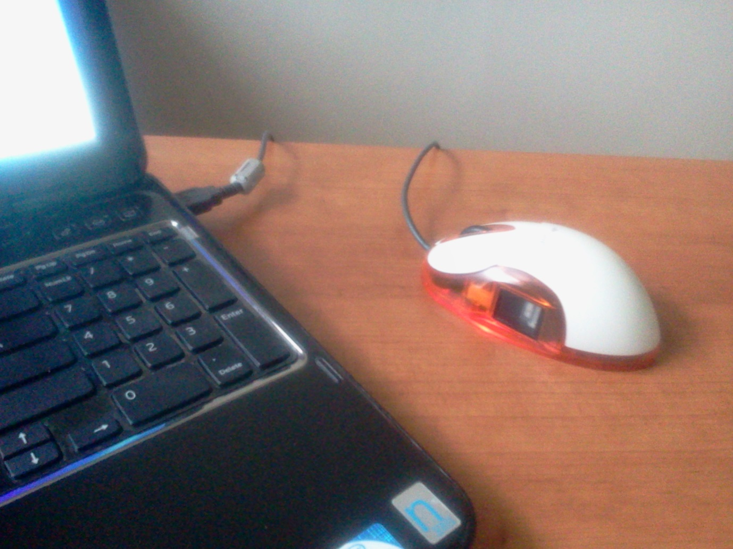
Picture 1: Prototype of access control system based on fingerprints using a mouse with integrated fingerprint scanner

- Access to data based on biometric recognition. A USB memory stick with integrated fingerprint scanner allows carrying data, software and other files in a secure manner (Picture 2). The memory stick is divided into public and private sections. Specific software is loaded in the memory and grants access to the private section after verification of a fingerprint. It is possible to store fingerprints from different individuals so the memory could be used only from the registered persons. Fingerprints are stored as hash functions rather than images. It is possible to install electronics certificate (electronic signature/PKI certificate) in the private memory and to use the device for multi-factor authentication. It is possible to use the device to exchange confidential or classified information using unsecured carriers.

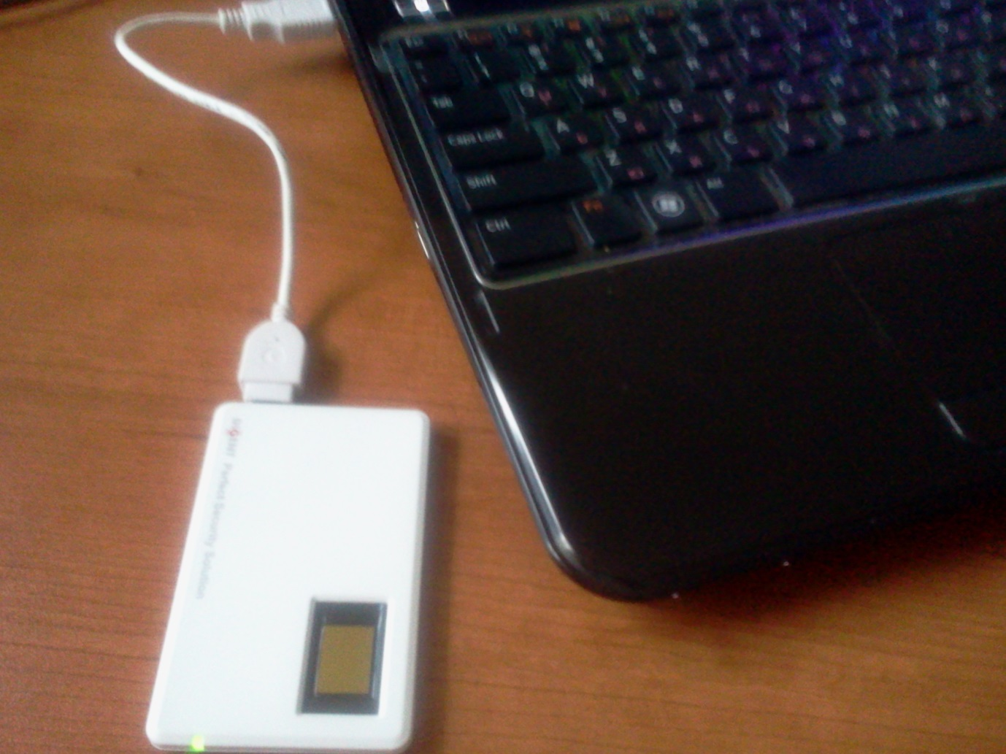
Picture 2: A USB memory stick with integrated fingerprint scanner allows carrying data, software and other files in a secure manner.
- Access to premises using chip card and fingerprint (picture 3). In this case the hash function related to the fingerprint is stored on a chip card. The electric lock is connected to a controller that performs the verification process (Fig. 2). It is possible to include also a PIN code in this multi-factor authorization. In a case with multiple locks and/or many users card IDs could be stored in a database instead in the memory of the controller.

- A simple registration system was developed using a card reader integrated with a fingerprint scanner to realize the verification process (picture 4).
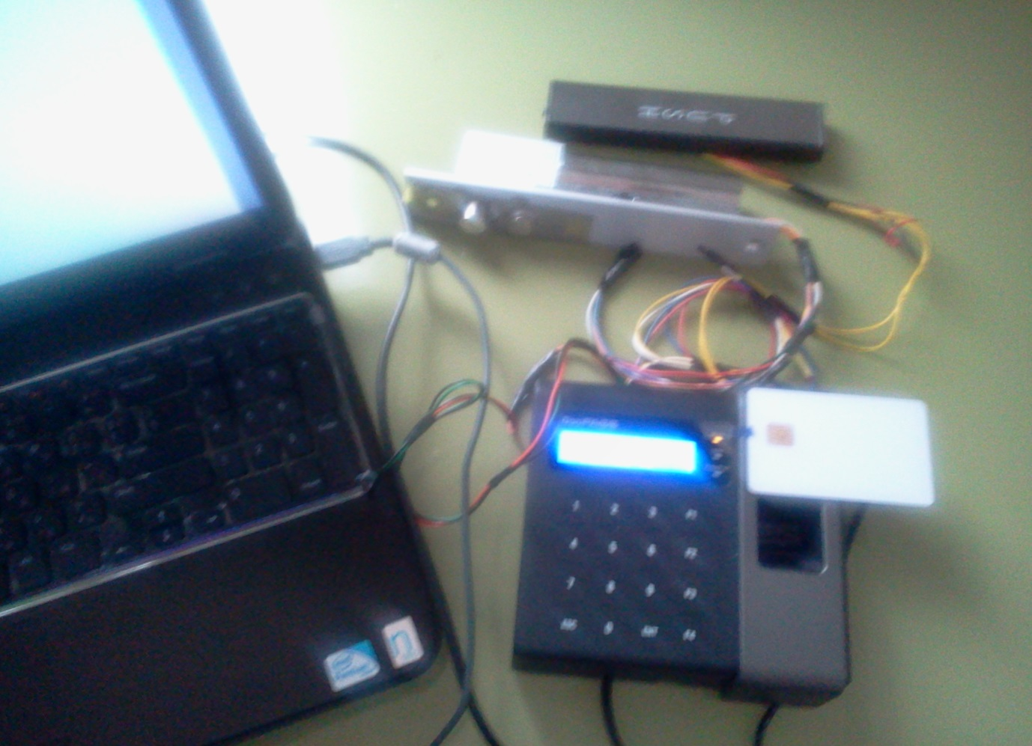
Picture 3: Door control system – controller with keyboard, card reader and fingerprint scanner connected to a computer and door lock.
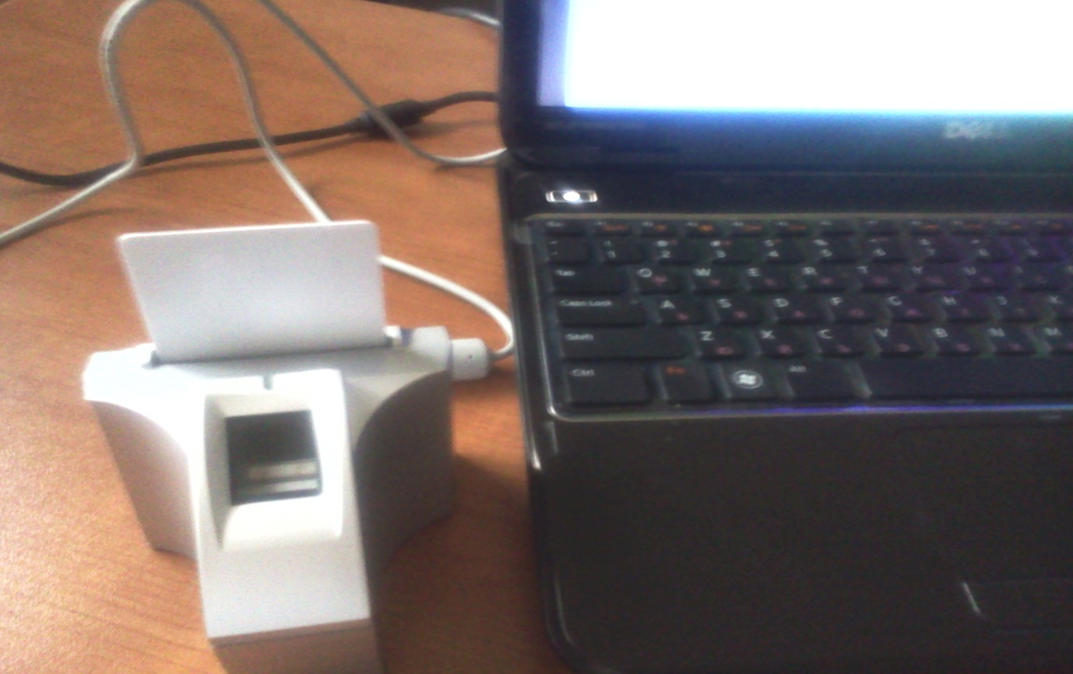
Picture 4: Prototype of registration system using a card reader integrated with a fingerprint scanner
Project results were presented and prototypes were demonstrated at the Bulgarian-Korean ITCC Final Report Meeting, Sofia University, December 17, 2012, Sofia.
Further development plans
There are plans to extend the project using other biometric identifiers using similar enrolment and verification processes as those at figures 1 and 2. The realization of these plans depends on the funding available.
During the exchange visits prof. Bae and assoc. prof. Spassov participated in meetings with Bulgarian and Korean companies and administrations to promote the project results and to identify opportunities for implementations of the prototypes. The list of organizations visited (delivered presentations on the project) and prominent individuals met are as follows:
In Bulgaria
- Sofia University Rector
- Former Deputy Governor of Varna Region
- Former Director of Coordination Center of Information Communication and Management Technologies
- Director of KOTRA Bulgaria
- HE Ambassador of Korea to Bulgaria
- ITCC management
- IT Director of Sopharma Trading, CISO at G4S – IT security consultant to Sopharma Trading
- IT Director Victoria Ins
- CEO and owner of InterConsult Bulgaria
- IT Director of Pension fund “Doverie”
- CEO of Information Services Plc
- IT Director of Ministry of Justice
- Head of International Cooperation Department of Academy of Ministry of Interior and Representative of the Institute of Criminology
In Korea
- Seoul Municipality
- Former Mayor of Seoul
- Director of Seoul City Museum
- CEO of Korea Information Certificate Authority Inc. (KICA)
- CEO of Digent
- CEO of MarkAny
Presentations at conferences
- International Conference on Security and Management (SAM'12), Las Vegas, USA, July, 2012
- International Conference “Automatics and Informatics”, School for young scientists “Innovation and Business Process Management”, October 2012, Sofia
- Bulgarian-Korean ITCC Final Report Meeting, Sofia University, December 17, 2012, Sofia
- Spring Scientific Conference of FMI, Sofia University, March 16, 2013, Sofia
In addition the project was presented to Information security department of UniCredit Bank in Bulgaria. Also Functional Rector of Sofia University requested a presentation in relation to an access control system project based on chip cards at the University.
Conclusions
The project is a result of the activities of Bulgaria-Korea IT Cooperation Center and prof. Popivanov and Mr. Yoon personal efforts and support. The goals of the project were achieved and resulted in the following benefits:
- Knowledge transfer from Korea to Bulgaria was realized
- Partnership among Sang-Myung University (prof. Bae) and Sofia University (assoc. prof. Spassov) was extended
- Working prototypes of access control systems were produced
- Relationships between the team and business and administrations was established
- Further development of the cooperation was outlined.

Contact Information:
Assoc. Prof. Kamen Spassov, PhD, MBA
Head of Master degree program „e-Business and e-Governance“
Department of Computing Systems
Faculty of Mathematics and Informatics, Sofia University “St. Kl. Ohridski”
Mobile phone: +359 898 422 585
email: kspasov@fmi.uni-sofia.bg

Prof. Bae Kyoung-yul, PhD
Dean of Academic Affairs
Department of Software
Sang-Myung University
Phone: 82-2-2287-5211
email: jbae@smu.ac.kr

